|  |  |  |  |
| --- | --- | --- | --- |
| Name:  Class: | ____________________________________  ________________ | | Date:_________ |
|  | **Year 11 Essential Mathematics**  / 46  %  **Unit 2**  **Topic – Statistics** | | |
| **Total Time:** | 55 minutes |  | |
| **Weighting:** | 10% |
| **Equipment:** | To be provided by the student: Pen, pencil, ruler,1 double sided A4 page of notes, scientific calculator | | |

**Full working out must be shown to get full marks. Attempt all questions.**

|  |
| --- |
| **Question 1**  **1 marks** |

**Categorical data is (Circle the correct answer):**

1. Data whose values are categories
2. Data that describes a measurable quantity
3. Data that can take any value within a certain range
4. All of the above

|  |
| --- |
| **Question 2 1 marks** |

**An example of numerical data is (Circle the correct answer):**

1. People’s names
2. Cost of a house
3. Number of pets
4. Both B and C

|  |
| --- |
| **Question 3 4 marks (1, 1, 2)** |

Two classes are marked on the same tests.

Class P has a mean of 65% and standard deviation of 5.

Class Q has a mean of 50% and standard deviation of 15.

1. Write a statement comparing the scores of the two classes, that is, who had the better scores?
2. Write a statement comparing the spread of the scores for the two classes.
3. Which class would you expect to have the highest score? Explain.

|  |
| --- |
| **Question 4 5 marks** |

This dot plot shows the foot length of a group of students.

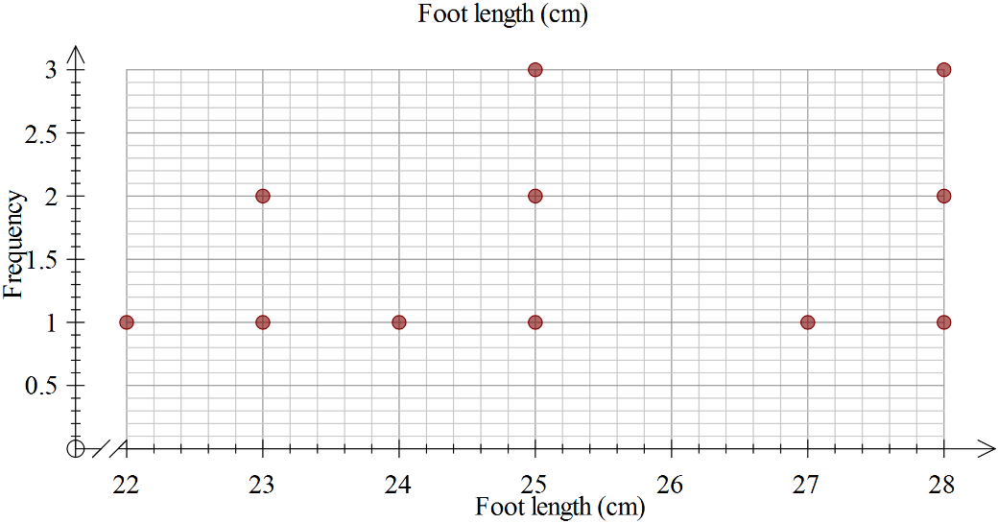

1. Calculate the range of the scores, showing your working.
2. Determine the mode.
3. Determine the median.
4. Calculate the mean, showing your working.

|  |
| --- |
| **Question 5 7 marks (3, 1, 1, 2)** |

|  |  |
| --- | --- |
| Class Interval for Blood Pressure | Frequency |
| 70 - <80 | 5 |
| 80 - <90 | 21 |
| 90 - <100 | 16 |
| 100 - <110 | 5 |
| 110 - <120 | 3 |

A routine medical check of the blood pressure of a group of men has been summarised in a Frequency table:

* 1. A picture containing chart

     Description automatically generatedDraw a histogram to show the above results with correctly labelled axes and a suitable title.
  2. How many people were in the survey?
  3. What was the most popular class interval?
  4. Describe the distribution of the data including skewness of the Data.

|  |
| --- |
| **Question 6**  **8 marks (1, 5 ,2)** |

1. Eric is in Class A, he scored 5 on the test. Label the two box plots with their class names.

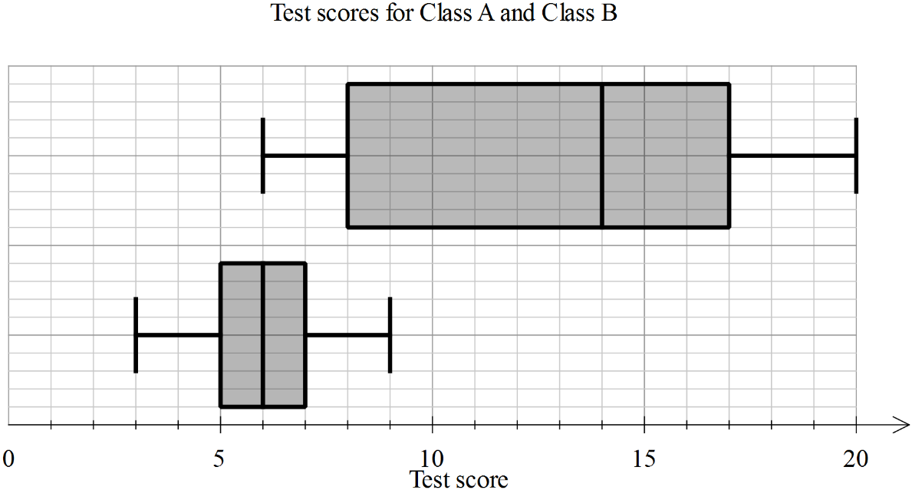

1. Use the table below to enter the appropriate values for each of the plots.

|  |  |  |
| --- | --- | --- |
| Statistic | Class A | Class B |
| Minimum |  |  |
| First quartile |  |  |
| Median |  |  |
| Third quartile |  |  |
| Maximum |  |  |

1. Calculate the range and interquartile range for each class, showing the working, in the table below.

|  |  |  |
| --- | --- | --- |
| Statistic | Class A | Class B |
| Range |  |  |
| Interquartile range |  |  |

|  |
| --- |
| **Question 7** **8 marks (2, 2, 2, 2)** |

Data Set 3 consists of data on the number of text messages sent in one month for 100 teenage girls who have a cell phone. Data Set 4 consists of data on the number of text messages sent in one month for 100 teenage boys who have a cell phone. Histograms of the two data sets are shown below.

|  |  |
| --- | --- |
|  |  |

1. Describe the data distribution of number of text messages for the girls (Data Set 3). Be sure to comment on symmetry, skewness and bimodality and unimodality, where applicable.
2. Are Data Set 3 and Data Set 4 centred in about the same place? If not, which one has the greater centre?
3. Which of Data Set 3 and Data Set 4 has greater spread? Explain.
4. On average, did the girls (Data Set 3) or the boys (Data Set 4) send more text messages? Explain

|  |
| --- |
| **Question 8**  **4****marks (3, 1)** |

Mum and Lucy were having an argument about the number of hours she spends on Facebook each night. They decided to record how many hours she spent on Facebook for one week. The results are shown below.

|  |  |  |  |  |  |  |  |
| --- | --- | --- | --- | --- | --- | --- | --- |
| **Day** | **Mon** | **Tues** | **Wed** | **Thurs** | **Fri** | **Sat** | **Sun** |
| **Hours on Facebook** | 4 | 2 | 2 | 1 | 6 | 5 | 8 |

1. Find the mode, median and mean for this data.
2. Which of these measures could Lucy use to show that she doesn’t spend too much time on Facebook?

|  |
| --- |
| **Question 9 8 marks (5, 3)** |

Peter and Kingi are arguing about which local rugby league team is the best. The points scored by their favourite teams in each match over the previous season are listed here:

Lions: 20, 10, 40, 12, 17, 20, 22, 20, 34, 19, 36, 18, 24, 12, 38

Cougars: 14, 18, 24, 39, 14, 4, 4, 14, 10, 13, 28, 22, 16, 18, 18

1. What is the best graph to use to show this data? Construct this graph
2. Which is the better team based on this data? Justify your answer using mathematical terminology about distribution shape and or the measures of central tendency.

**END OF TEST**